**Edukujme sa navzájom**

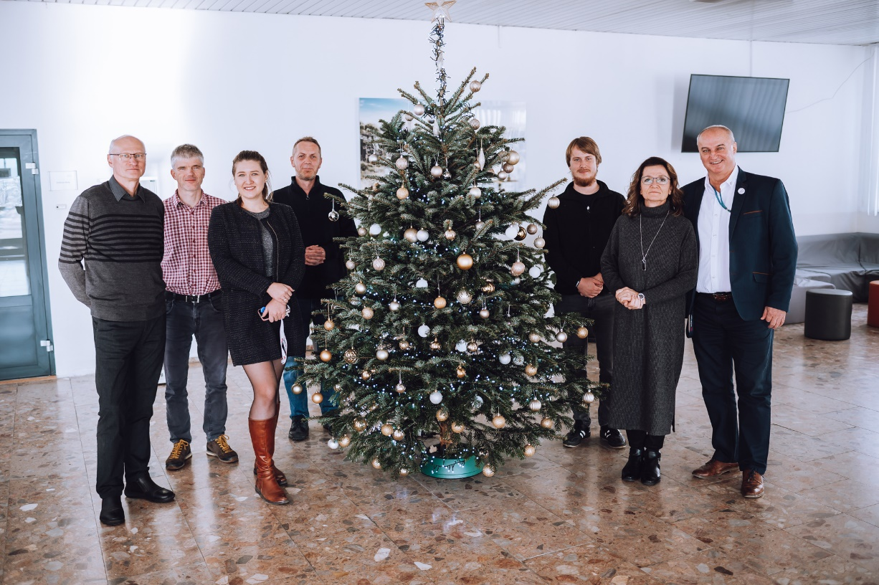**First visit from the partner school within the Erasmus+ project ‘Edukujme sa navzájom‘.**

**Bratislava, 4th December 2023** – A significant milestone in the project was achieved when the first group of teachers from the partner school visited SSOŠA DA. This mutual visit is part of the Erasmus+ project titled “Let’s Educate Each Other,” which successfully received a grant from the Erasmus+ fund under the number 2023-1-SK01-KA210-VET-000158751.

The aim of this innovative project is to increase the attractiveness of educational programs and the teaching process in schools, with a focus on fields such as electromechanics, electronics mechanics, electrical engineering, inspection technician, and others. Special emphasis is placed on thematic areas like heat pumps, robotics, and renewable energy sources, which are crucial for the future of technical education.

During the visit, teachers from the partner school, the Secondary Agricultural School and the Secondary Vocational School of Refrigeration and Air Conditioning Technology in Kostelec nad Orlicí, had the opportunity to learn more about the dual education system and the practical aspects of their field. Teachers from both schools actively exchanged experiences and best practices in education, creating a space for mutual professional development.

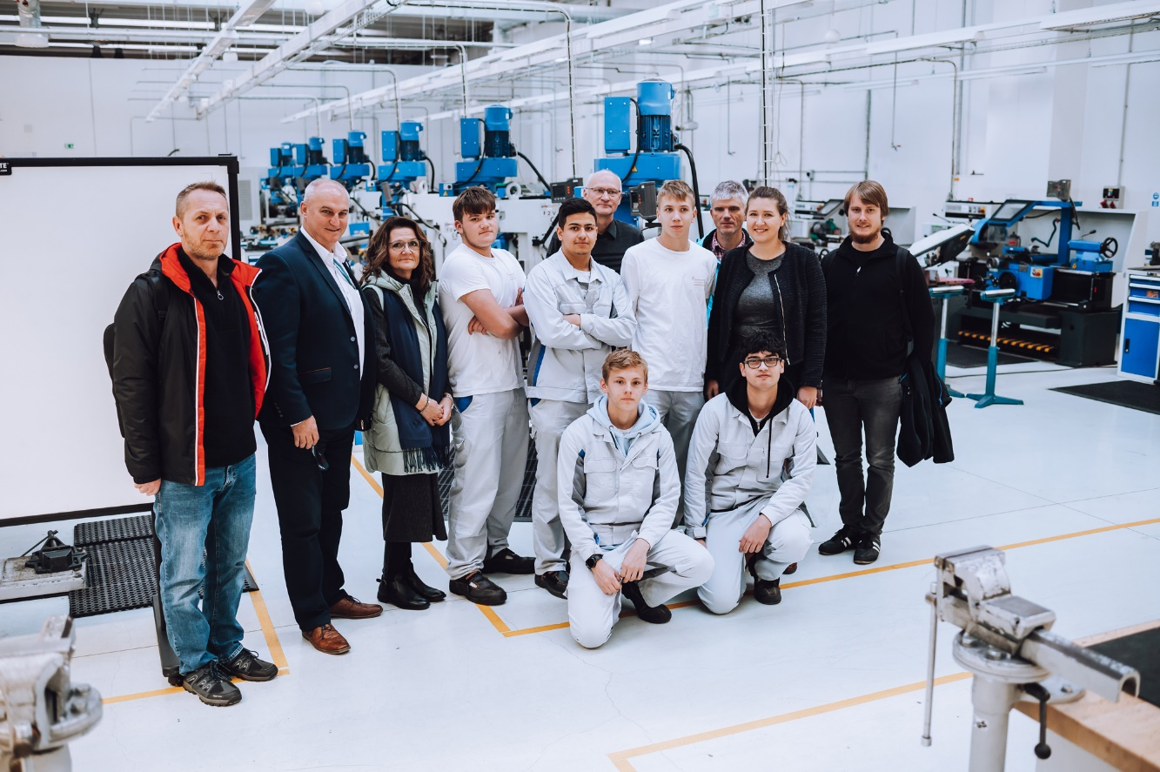The project “Edukujme sa navzájom” will bring significant benefits to both schools, strengthen their mutual cooperation, and enhance the quality of teaching in fields that are crucial for the current and future needs of the labor market. This initiative highlights the importance of international cooperation in education and is another step towards supporting innovation and modernization in vocational education.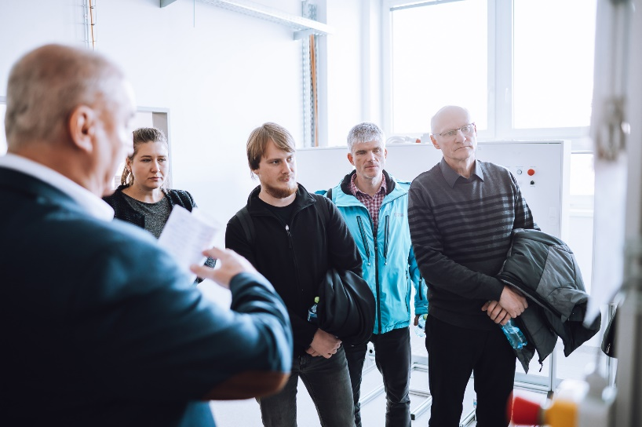 The project “Edukujme sa navzájom” will continue with the hope of building on its successful beginnings and bringing enrichment to all participating students and teachers.