Edukujme sa navzájom

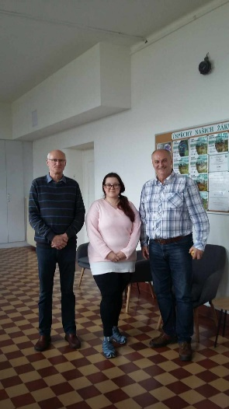
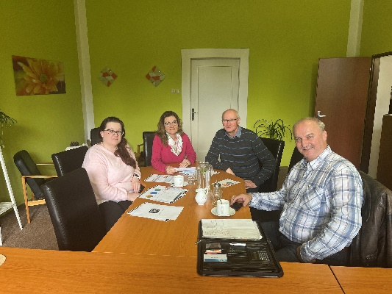
Second visit to SZeŠ a SOU CHKT Kostelec nad Orlicí within the Erasmus+ project “Edukujme sa navzájom”.

Kostelec nad Orlicí, 25th April 2024 – Another significant milestone in the project was achieved when a group of teachers from SSOŠA DA visited the partner school, the Secondary Agricultural School and the Secondary Vocational School of Refrigeration and Air Conditioning Technology. This mutual visit is part of the Erasmus+ project titled “Edukujme sa navzájom,” which successfully received a grant from the Erasmus+ fund under the number 2023-1-SK01-KA210-VET-000158751.
The aim of this innovative project is to increase the attractiveness of educational programs and the teaching process in schools, with a focus on fields such as electrical engineering mechanics, mechatronics mechanics, and others. Special emphasis is placed on thematic areas like heat pumps, robotics, and renewable energy sources, which are crucial for the future of technical education.
During the visit, teachers from both schools familiarized themselves with the results of the questionnaire survey and focused on implementing the findings into teaching, such as purchasing new teaching aids, acquiring equipment necessary for teaching, creating new teaching materials, and adjusting the curriculum.
The project “ Edukujme sa navzájom ” will bring significant benefits to both schools, strengthen their mutual cooperation, and enhance the quality of teaching in fields that are crucial for the current and future needs of the labor market, with an emphasis on the newly opened field of electrical engineering mechanics for refrigeration equipment and heat pumps. This initiative highlights the importance of international cooperation in education and is another step towards supporting innovation and modernization in vocational education.
The project “ Edukujme sa navzájom ” will continue with the hope of building on its successful beginnings and bringing enrichment to all participating students and teachers.

